Optimal dispatch of flexible energy resources using energysim

In this example, we will show co-simulation of intelligent distributed energy resources and their optimal dispatch. Specifically, we consider, how to optimally dispatch P2G electrolyzer and P2H heat pump. This case study has been taken directly from MSc work of Caner Yagci [[Investigating Hidden Flexibilities Provided by Power-to-X Considering Grid Support Strategies | TU Delft Repositories](https://repository.tudelft.nl/islandora/object/uuid%3Af5dd1a15-d66d-4fc9-b2cf-15129c6c2800)]

We take the study case to be a multi-stakeholder study case, whereby, each P2X owner has their own interest in mind. They look at their own system and convey relevant information to an optimal controller that can then use that info to set dispatch set points.

Each of the FER is modelled using OpenModelica. Using OpenModelica, we can develop a dynamic physical model of the FER that is able to accurately reflect the workings of the FER. We have also modelled an internal storage system and an intelligent adaptive power level controller that interacts with the high level optimal controller. This leads to a two-level control simulation problem.

Because this is such a complex system, we employ cosimulation as our tool of choice. By modelling the dynamic models of FER in OpenModelica, we can package these models as Functional Mockup Units, which allows us to easily exchange models, while also addressing any concerns related to exposing sensitive model information or other IP related restrictions. This complex problem can be easily implemented using energysim as will be shown.

The optimal controller in this case is a pandapower network performing an OPF calculation. This was done so that we don’t “re-invent the wheel” when it comes to simple optimal control.

The entire system consists of:

1. P2G model
   1. Electrolyzer model
   2. Storage Model
   3. Controller
2. P2H model
   1. Heat pump model
   2. Storage Model
   3. Controller
3. Electrical grid
   1. Load
   2. External Grid
   3. Transformer
   4. Wind
   5. Solar PV

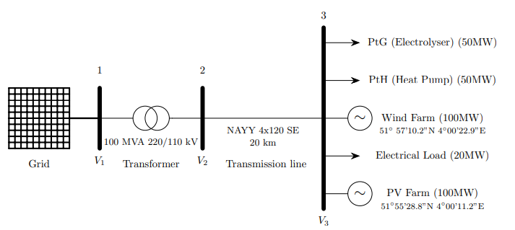

The overall hierarchical optimal dispatch problem is shown here summarized in the flowchart

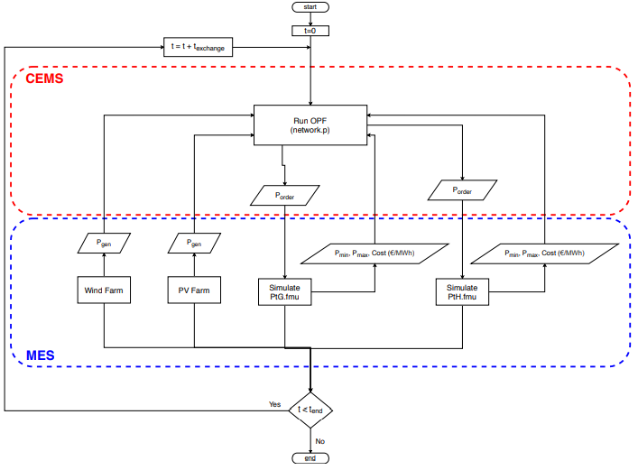

**How to run the script**

1. Make sure energysim is installed via pip
2. Clone the repository
3. In examples folder, run the main.py file.

**Optimal Control**

The FER are provided set points calculated by the pandapower OPF module. These set points are calculated based on the cost curves for load change provided by the FER and the network conditions. Although in this case, we have chosen a rather simplistic single bus system and two FER, the cosimulation based approach can be easily applied to much larger systems as easily as this one.

**Results**

